Dear all,
There are few places remaining for two Belgian events organised during La Semaine de la Francophonie. Please note that these two events are free :
1. On the 19th March, a conference by Bill Alder on the life and writings of Georges Simenon (in partnership with the European Commission), will be followed by a drink reception with Belgian beers
2. On the 18th March, a Stand-Up Comedy with 3 Belgian comedians (event in French).
Please find below my signature more information about these two events. If you are interesting in attending, reply to this email with a confirmation of participation and the names of the participants.
I look forward to hearing from you.
Have a lovely day.

Aurore

Aurore CRETEL
Culture & Events

Wallonia-Brussels International
Embassy of Belgium
17 Grosvenor Crescent
London SW1X 7EE
+44 (0) 207 235 0616

www.wallonia.co.uk
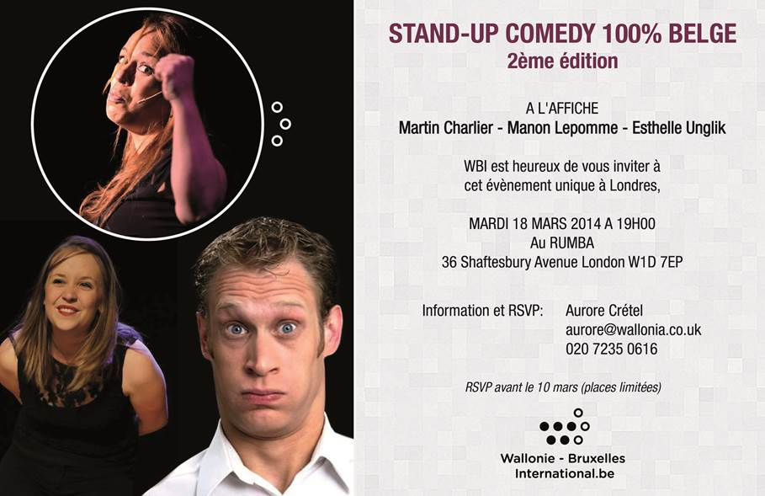
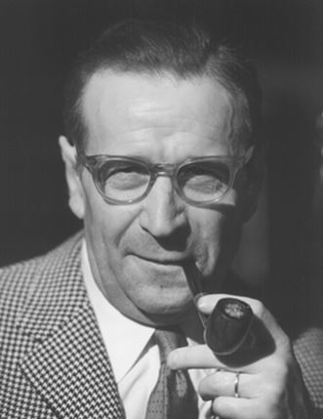
'The life and writings of Georges Simenon'
Lecture by Bill Alder
6.30 pm on Wednesday 19th March 2014
At the Europe House, London

Wallonia-Brussels International and the European Commission Representation in the UK are delighted to invite you to a lecture (in English) by Bill Alder on Georges Simenon.
Belgian novelist Georges Simenon (1903 - 1989) became a phenomenally successful author of crime fiction through his creation Inspector Maigret.
Bill Alder is an associate lecturer in French with the Open University. He has published articles in English and French on Maigret and Simenon in American, British and Belgian journals. His recent book Maigret, Simenon and France has been nominated for an 'Edgar' award by the Mystery Writers of America.

Through a presentation of the life of Simenon, Bill Alder will examine how the author's childhood and adolescence in Liège influenced his writing over half a century and will consider why the Maigret series and Simenon's other novels met with international success and remain popular today in fresh new translations.

The conference will be followed by a drink reception. Entrance to this event is free but places are limited.
To reserve a place, please email Aurore Crétel: aurore@wallonia.co.uk

Location:
European Commission Representation UK
Europe House
32 Smith Square
London SW1P 3EU
(Nearest tube station: Westminster, 5-minute walk)

This event is part of la Semaine de la Francophonie. For more information : www.semaine-de-la-francophonie-au-royaume-uni.com

